CRM Application For Jewel   
Management- (Developer)

COLLEGE NAME : SRI RAMAKRISHNA COLLEGE OF ARTS AND

SCIENCE FOR WOMEN

COLLEGE CODE : BRU28

Team id : NM2025TMID24232

Team Leader Name : POORNIMA S

Email **: srcw23218B31@srcw.ac.in**

**NMID: 615C88E2B9BA9A19855441C03038055A**

Team Member **:** ASWATHA R

Email**: srcw23218B06@srcw.ac.in**

**NMID: 6F5B1E63310DF4E91094EB3C16BA2AD8**

Team Member : ABINAYA L

Email**: srcw23218B01@srcw.ac.in**

**NMID:1F06DE90882AE348CB64488666596982**

Team Member **:** PRINCY S

Email**: srcw23218B32@srcw.ac.in**

**NMID: E74E5B45944A442AC284807E69AE6068**

Team Member **:** VIDHYA S

Email**: srcw23218B49@srcw.ac.in**

**NMID:87C12F89E0F4330A97B45A4832361DD1**

**Project Overview – CRM Application for Jewel Management**

1. Introduction

Jewelry businesses often face challenges in managing customer relationships,   
sales, inventory, and after-sales services effectively. Traditional methods like   
paper records or simple spreadsheets are inefficient and prone to errors. To   
overcome these challenges, a CRM (Customer Relationship Management)   
application tailored for jewel management helps streamline customer   
interactions, track sales, manage inventory, and enhance customer satisfaction.

This project aims to design and develop a CRM application specifically for   
jewelry shops and showrooms, integrating both customer engagement and   
inventory management features into a single platform.

2. Objectives

To provide a centralized system for managing customer information and   
purchase history.

To automate jewelry sales, billing, and order tracking.

To maintain accurate records of jewelry inventory, including gold, silver,   
diamonds, and custom designs.

To track customer preferences and suggest personalized offers.

To generate reports for sales, profits, and stock management.To improve   
customer loyalty through better after-sales support and reminders (e.g.,   
polishing, warranty, festivals).

3. Scope

The CRM application will include the following modules:

1. Customer Management – Customer profiles, purchase history, preferences.

2. Inventory Management – Adding, updating, and tracking jewelry stock.

3. Sales & Billing – Automated invoice generation, payment tracking.

4. Order Management – Custom orders, repair services, delivery tracking.

5. Loyalty & Offers – Discounts, festival offers, and loyalty points.

6. Reports & Analytics – Daily/weekly/monthly sales reports, stock alerts.

7. Admin Panel – Manage users, roles, and permissions.

4. Technology Stack (suggested)

Frontend: ReactJS / Angular / HTML, CSS, JavaScript

Backend: Node.js / Java / Python (Django/Flask)

Database: MySQL / PostgreSQL / MongoDBCRM Integration Tools: Salesforce

APIs (optional) or custom-built modules

Hosting/Deployment: AWS / Azure / Local server

5. Benefits

Easy tracking of customer data and preferences.

Efficient jewelry stock and sales management.

Reduction in manual errors and duplicate records.

Improved customer satisfaction and retention.

Business insights through automated reports.

6. End Users

Jewelry shop owners/managers.

Sales executives.

Customers (through a possible customer-facing portal or app).

MILESTONE1:SALESFORCE DEVELOPER ACCOUNT CREATION

**Activity 1** : Creating Developer Account

Creating a developer org in salesforce.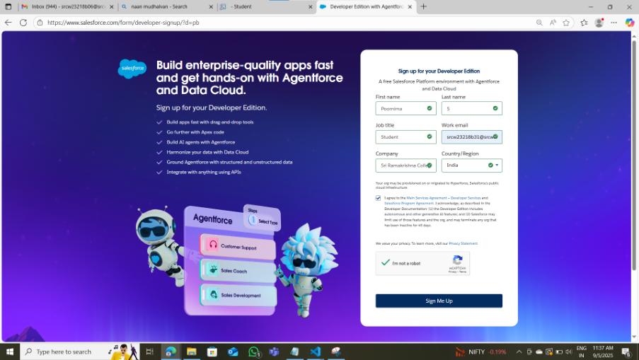

1. Go to <https://developer.salesforce.com/signup>

2. On the sign up form, enter the following details :

**Activity 2 :**Account Activation

1. Go to the inbox of the email that you used while signing up. Click on the

Reset Password to activate your account. The email may take 5-10mins.

MILESTONE 2 :OBJECT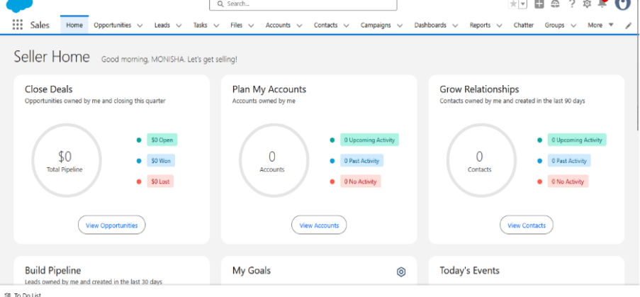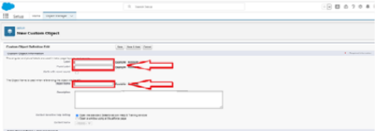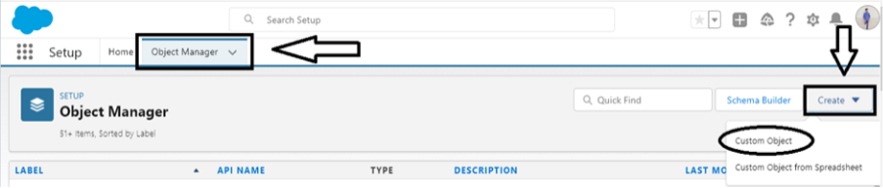

**Activity 1 :**Creating jewel customer object

The purpose of creating a Jewel Customer custom object is to store and manage

information about Customer.

1. From the setup page >> Click on Object Manager >> Click on Create >>

Click on Custom Object.

1. Enter the label name : Jewel Customer

2. Plural label name : Jewel Customers

1. Enter Record Name Label and Format

●Record Name >> Customer name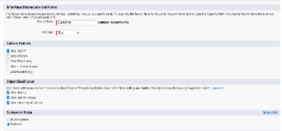

●Data Type >> Text

1. Click on Allow reports.

2. Allow search and click Save.

1. Click on Allow reports.

1. Allow search and click Save.

**Activity 2: Create a Item Object**

The purpose of creating a Item object is to manage the inventory of gold and

silver items.

To create an object:

1. From the setup page >> Click on Object Manager >> Click on Create

>> Click on Custom Object.

1. Enter the label name >> Item

2. Plural label name >> Items

3. Enter Record Name Label and Format

●Record Name >> Item Id

●Data Type >> Auto Number

●Display Format >> Item-{00}

●Starting Number >> 1

1. Click on Allow reports.

1. Allow search >> Save.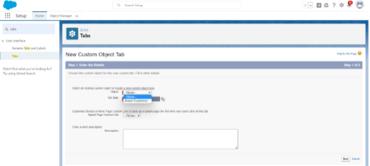

**Note:Create 3 more objects with label names as Customer**

**Order,Price,Billing**

**(**Use “Auto Number” as a data type for Customer Order,Price,Billing).

MILESTONE 3: TABS

**Activity 1: Create a Custom Tab**

To create a Tab:(Customer)

1. Go to setup page >> type Tabs in Quick Find bar >> click on tabs >>

New (under custom object tab)

2.Select Object(Jewel Customer) >> Select any tab style >> Next (Add to

profiles page) keep it as default >> Next (Add to Custom App) keep it as default

>> Save.

**Activity 2 : Create a Tab:(item)**

1. Go to setup page >> type Tabs in Quick Find bar >> click on tabs >>

New (under custom object tab)

2. Select Object(Item) >> Select the tab style >> Next (Add to profiles

page) keep it as default >> Next (Add to Custom App) keep it as default

>> Save.

Note: Now create tabs for Customer Order, Price, Billing objects.

MILESTONE 4 :THE LIGHTING APP

**Activity 1 : Create a Lighting App**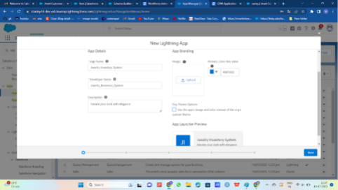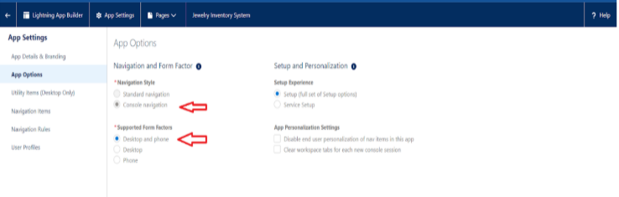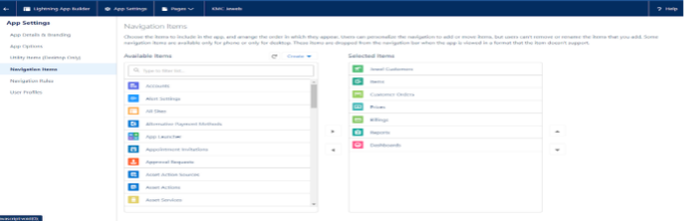

To create a lightning app page:

1. Go to setup page >> search “app manager” in quick find >> select “app

manager” >>

2. click on New lightning App

3. Then click Next >> (App option page)Set Navigation Style as Console

Navigation >> Next.

(Utility Items) keep it as default >> Next.

1. To Add Navigation Items:

Search for the item in the

(JewelCustomer,Item,CustomerOrder,Price,Billing,Reports, Dashboard)

from the search bar and move it using the arrow button ? Next? Next.

Search profiles (System administrator) in the search bar >> click on the arrow

button >> save & finish.

MILESTONE 5: FIELDS

**Activity 1: Creating Lookup Relationship**

1. Go to the setup page >> click on object manager >> type object

name(Customer Order) in the quick find bar >> click on the object.

2. Click on fields & relationship >> click on New.

3. Select “Lookup relationship” as data type and click Next.

4. Select the related object “ Jewel Customer ”.

5. Give Field Label as “Customer” and click Next.

6. Next >> Next >> Save.

**Activity 2 : Creating a Master-Detail Relationship**

To Create a Master-Detail relationship :

1. Go to the setup page >> click on object manager >> type object

name(Customer Order) in the quick find bar >> click on the object.

2.Click on fields & relationships >> click on New.

3.Select “Master-Detail relationship” as data type and click Next.

4.Select the related object “ Item”.

5.Give Field Label as “Item” and click Next.

6.Next >> Next >> Save.

**Activity 3: Creating Text Field in Jewel Customer Object**

To create fields in an object:

1. Go to setup >> click on Object Manager >> type object name(Jewel

Customer ) in quick find bar >> click on the object.

1. Now click on “Fields & Relationships” >> New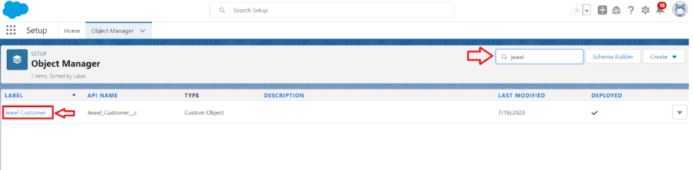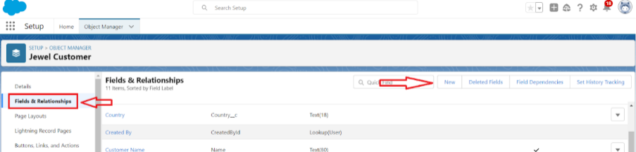

1. Fill the above as following:

●Field Label: City

●Length : 20

●Field Name : gets auto generated

●Click on Next >> Next >> Save and new.

**Activity 4 : Creating the Phone field in object Jewel Customer**

To create fields in an object:

1. Go to setup >> click on Object Manager >> type object name(Jewel

Customer ) in quick find bar >> click on the object.

2. Now click on “Fields & Relationships” >> New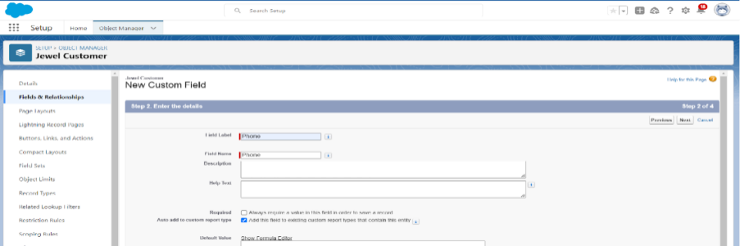

3. Select Data type as “Phone” and click Next.

4. Given the Field Label as “ Phone”.

1. Field Name will be auto populated, and click on Next >> Next >> Save &

new.

**Activity 5: Creating the Email field in object Jewel Customer**

To create fields in an object:

1. Go to setup >> click on Object Manager >> type object name(Jewel

Customer ) in quick find bar >> click on the object.

2. Now click on “Fields & Relationships” >> New

3. Select Data type as “Email” and click Next.

4. Given the Field Label as “ Email”.

1. Field Name will be auto populated, and click on Next >> Next >> Save.

**Activity 6 : Creating the number field in Item object**

To create fields in an object:

1. Go to setup >> click on Object Manager >> type object name(Item) in

quick find bar? click on the object.

2. Now click on “Fields & Relationships” >> New

3. Select Data type as “Number” and click Next.

4. Given the Field Label as “ Purity” and length as “ 2 ”.

1. Field Name will be auto populated, and click on Next >> Next >> Save.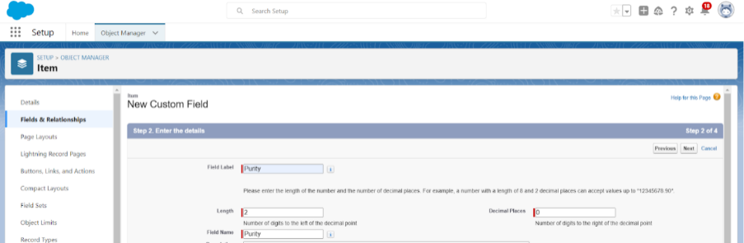

**Activity 7 : Creating Picklist Field in Item Object**

To create fields in an object:

1. Go to setup >> click on Object Manager >> type object name(Item) in

quick find bar>> click on the object.

2. Now click on “Fields & Relationships” >> New.

3. Select Data type as “Picklist” and click Next.

4. Enter Field Label as “Item Type”.

5. In values select “Enter values(Gold,Silver), with each value separated by

a new line" and enter values as shown below.

1. Click Next? Next ? Next ? Save .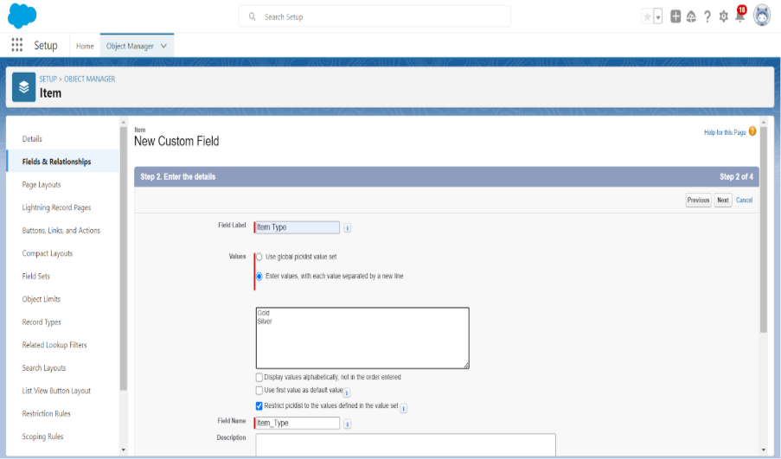

**Activity 8: Creating Currency Field in Price Object**

To create fields in an object:

1. Go to setup >> click on Object Manager >> type object name(Price) in

quick find bar >> click on the object.

2. Now click on “Fields & Relationships” >> New.

3. Select Data type as “Currency” and click Next.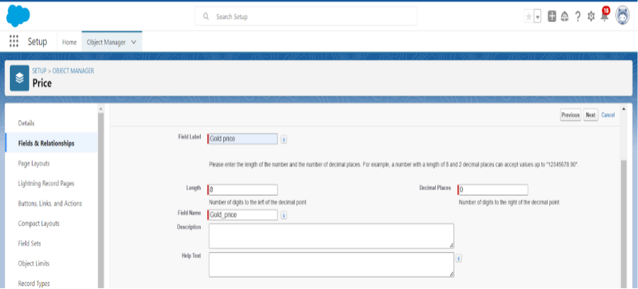

4. Enter Field Label as “Gold Price” and length as “ 8”and decimal 0.Field

name will be auto generated.

5. Click Next >> Next >> Next >> Save .

**Activity 9 : Creating Formula Field(Cross Object) in Item Object**

To create fields in an object:

(Note:Create a Lookup Relationship in Item Object to Price Object with Field

Name:Prices)

1. Go to setup >> click on Object Manager >> type object name(Item) in

quick find bar? click on the object.

2. Now click on “Fields & Relationships” >> New.

3. Select Data type as “Formula” and click Next.

4. Give Field Label and Field Name as “Gold Price” and select formula

return type as “Currency” and click next.

5. Under Advanced Formula write down the formula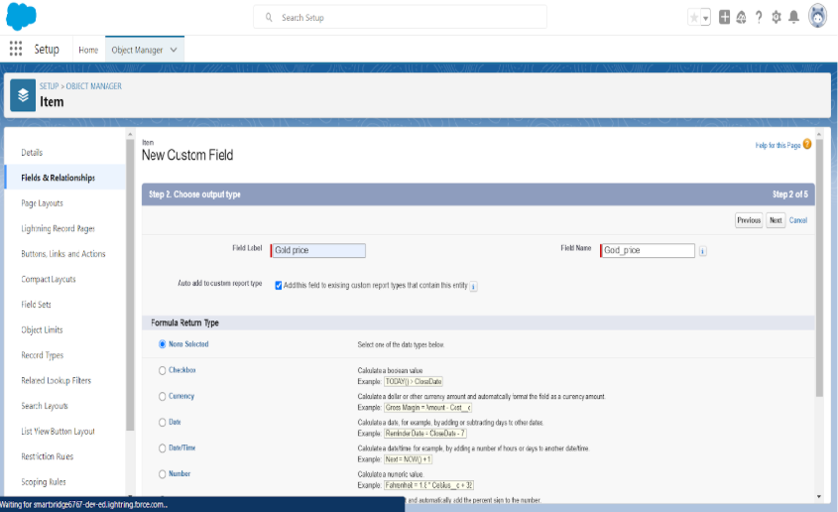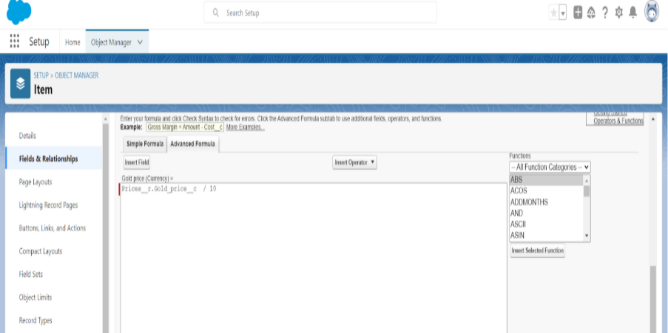

:Prices__r.Gold_price__c / 10.

6. click “Check Syntax” and Next >> Next >> Save & New.

**Activity 10 : Creating Remaining Fields in Objects**

Now create the remaining fields using the data types mentioned.

**Activity 11: Schema Builder**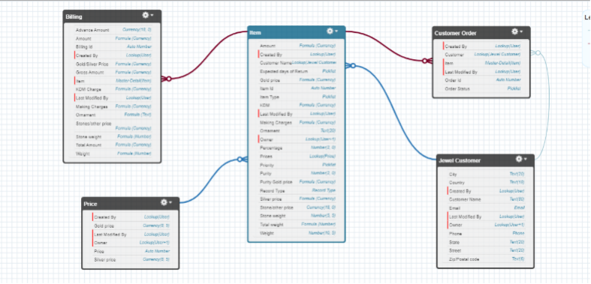

Schema Builder is a powerful tool within Salesforce that allows you to   
visualise, explore, and design the relationships between objects in your   
Salesforce organisation. It provides a graphical representation of the data model,   
making it easier to understand the structure and connections between different   
objects.

**Activity 12 : Creating the Field Dependencies**

Use case:

Field Dependencies are used to create relationships between fields within an   
object. They allow you to control the visibility and availability of fields based

on the values selected in other fields.

1. Go to setup >> click on Object Manager >> type object name(Item) in   
 quick find bar >> click on the object.

2. Click on Fields & Relationships and click on the Priority field.

3. Search for Field Dependencies and click on New.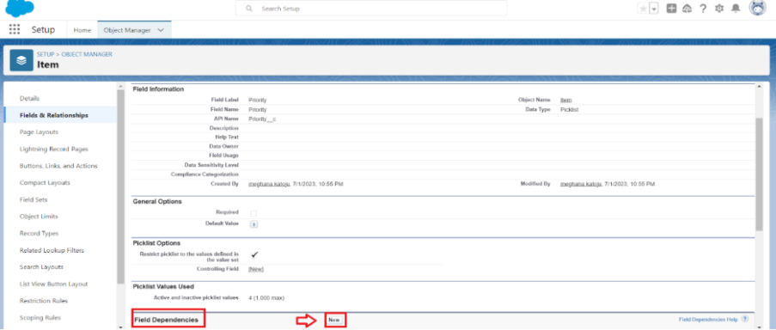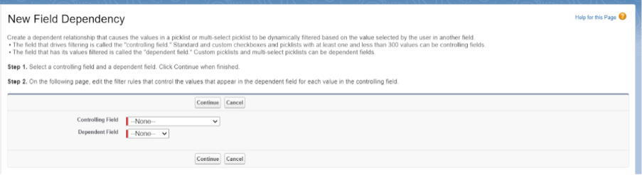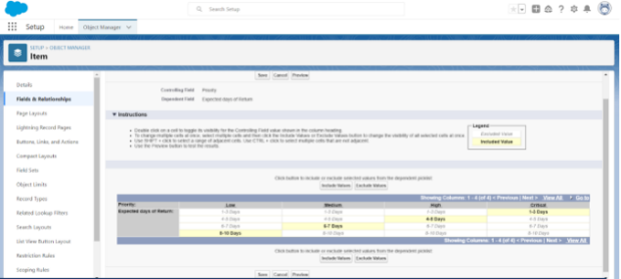

4. Select Controlling Field as “Priority” and Depending field as “Expected   
 Days of Return” >> Continue.

5. Select the “Expected Days of Return” values of related Priority values

and Click on Include Values >> Save.

**Activity 13 : Creating the validation rule**

**Creating the validation rule**

Creating the validation rule for Postal Code field in Jewel Customer object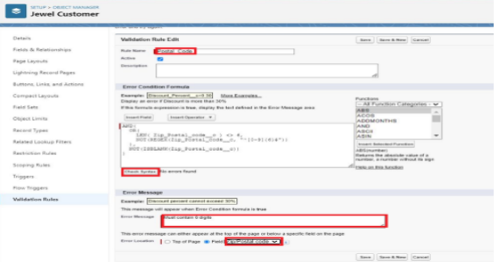

Note : check whether the fields mentioned in the formula field are created or not

, if not go to activity 10 and create those fields mentioned in Jewel Customer   
object.

1. Go to setup >> click on Object Manager >> type object name(Jewel   
 Customer ) in quick find bar>> click on the object.

2. Click on the validation rule >> click New.

3. Enter the Rule name as “Postal Code “.

4.Insert the Error Condition Formula as : -

AND(   
 OR(   
 LEN( Zip_Postal_code__c ) <> 6, NOT(REGEX(Zip_Postal_code__c,   
"^[0-9]{6}$"))),   
 NOT(ISBLANK(Zip_Postal_code__c))   
 )   
)

1. Enter the Error Message as “Must contain 6 digits”, select the Error   
location as Field and select the field as “Zip/Postal code”, and click

Save.

Create Validation rule for Item object.

1. Enter Rule name as “ValidationRule For Item“.

2. Insert the Error Condition Formula as : -

OR( ISBLANK( Amount__c ) , ISBLANK( Customer_Name__c )

,ISBLANK( Gold_price__c ),ISBLANK( KDM__c ),ISBLANK(   
Ornament__c ),ISBLANK( Percentage__c ),ISBLANK(   
Making_Charges__c ),ISBLANK( Prices__c ),ISBLANK(   
Stone_weight__c ),ISBLANK( Silver_price__c ),ISBLANK(   
Stone_other_price__c ),ISBLANK( Stone_weight__c ),ISBLANK(   
Weight__c ))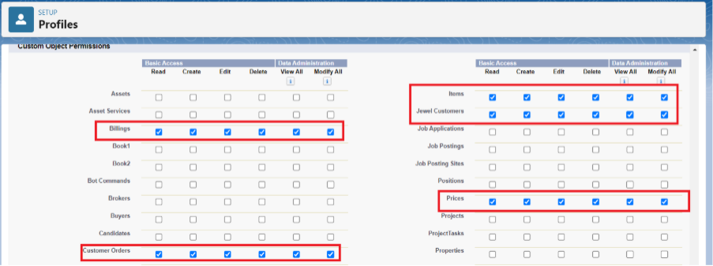

3. Enter the Error Message as “Please fill Required fields”, select the Error   
 location as Top of Page and click Save.

MILESTONE 6 : PROFILES

**Activity 1: Gold Smith Profile**

1. Go to setup >> type profiles in quick find box >>click on profiles ? clone   
the desired profile (System Administrator) >> enter profile name (Gold   
Smith) >> Save.

2. While still on the profile page, then click Edit.

3.Scroll down to Custom Object Permissions and Give access permissions   
for Jewel Customer,Item,Customer Order,Prices,Billings .

4.Scroll down and Click on Save.

**Activity 2: Worker Profile**

1. Go to setup >> type profiles in quick find box >> click on profiles >>   
clone the desired profile (Salesforce Platform User) >> enter profile name   
() >> Save.

2. While still on the profile page, then click Edit.

3. Scroll down to Custom Object Permissions and Give access permissions   
 for Items,Price and Customer Order objects.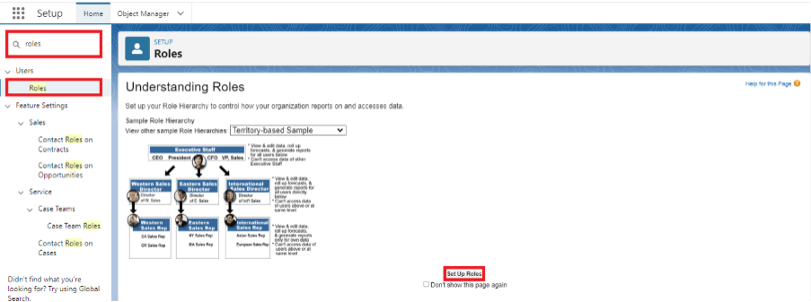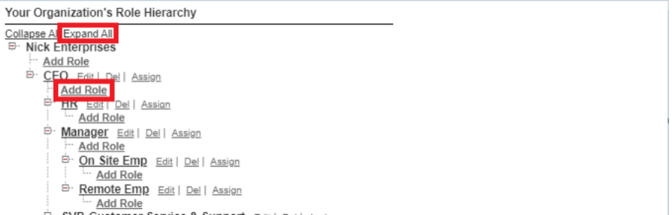

4. Scroll down and Click on Save.

MILESTONE 7: ROLES

**Activity 1: Creating Gold Smith Role**

1. From setup ,Go to quick find >> Search for Roles >> click on set up

roles.

1. Click on Expand All and click on add role under whom this role works.

1. Give Label as “Gold Smith” and Role name gets auto populated. Check   
 to whom this role (Gold Smith) reports. Then click on Save.

**Activity 2: Create one more role as Worker which reports to Gold Smith.**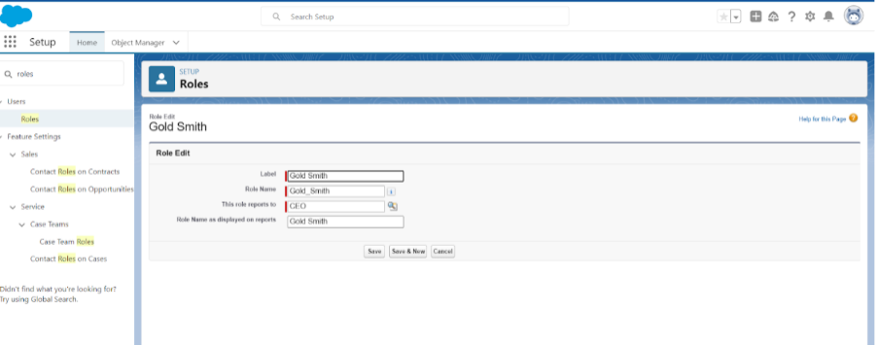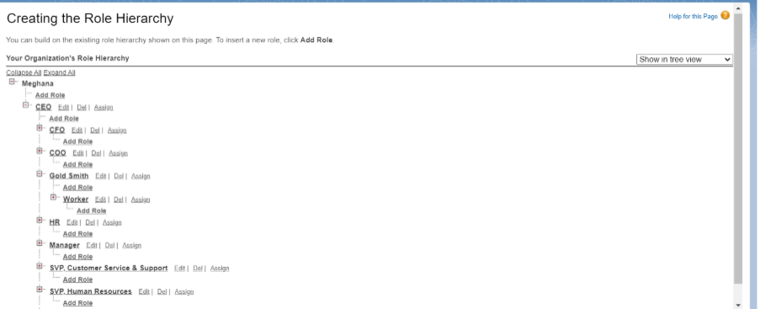

MILESTONE 8: USERS

**Activity 1: Create User**

1. Go to setup >> type users in quick find box >> select users >> click New

user.

2. Fill in the fields

1. First Name : Niklaus

2. Last Name : Mikaelson

3. Alias : Give a Alias Name

4. Email id : Give your Personal Email id

5. Username : Username should be in this form: text@text.text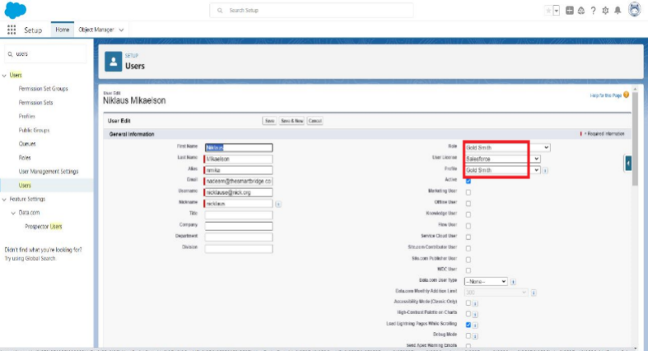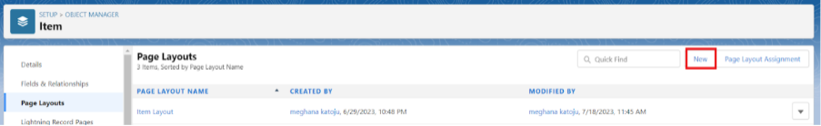

6. Nick Name : Give a Nickname

7. Role : Gold Smith

8. User licence : Salesforce

9. Profiles : Gold Smith

1. Save.

**Note:**

Create two more users as mentioned in activity 2 using the same profile.

MILESTONE 9:PAGE LAYOUTS

**Activity 1: To Create a Gold Page layout**

Go to Setup >> Click on Object Manager >> Search for the object (Item) >>

From drop down click on Edit.

Click on Page layout >> Click on New.

Give Page layout Name as “Page Layout for Gold” and click on Save and New.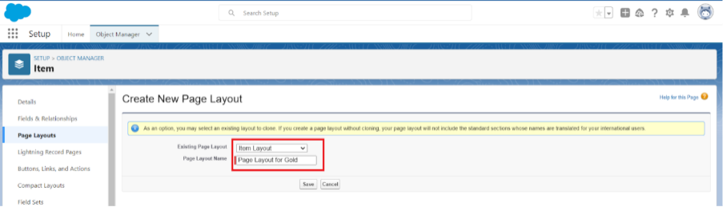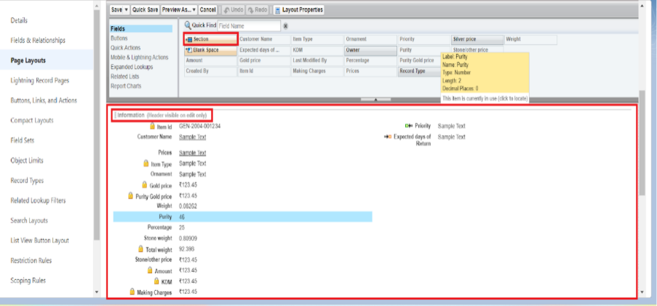

Arrange the field as shown in the Information Section ,remove fields which are

related to Silver and click Ok.

Click Save.

Make sure your page layout looks like the picture above.

**Activity 2:To Create A Silver Page Layout**

1. Go to Setup >> Click on Object Manager >> Search for the object (Item)

>> From drop down click on Edit.

2. Click on Page layout >> Click on New.

3. Give Page layout Name as “Page Layout for Silver” and click on Save.

4. Arrange the field as shown in the Information Section ,remove fields

which are related to Gold and click Ok.

MILESTONE 10:RECORD TYPES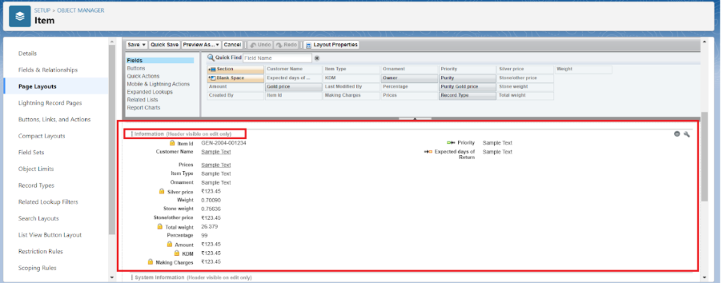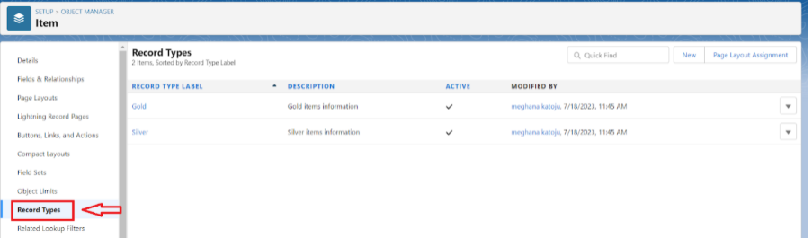

**Activity :To Create A Record Type**

1. Go to setup >> click on Object Manager >> type object name(Item) in

quick find bar? click on the object.

2. Click on the Record Types >> click New.

3.Select Existing Record as “Master”,Record type Label as

“Gold”,Description as “Gold items information”.

1. Scroll down and check for the Gold Smith,Worker JW & System   
 Administrator profile and click on Next.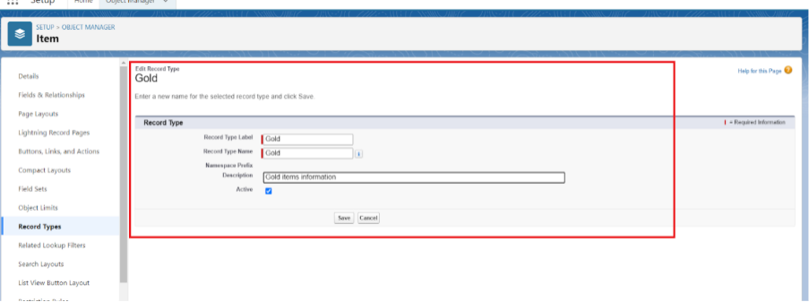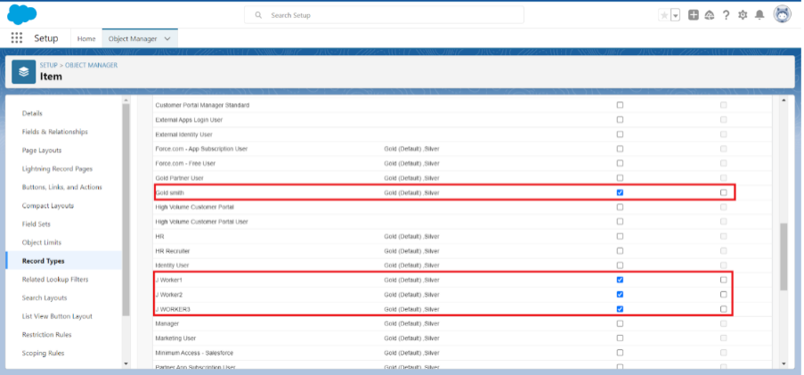

1. Select “Apply a different layout for each profile”, and change page layout   
 to “Page Layout for Gold“for Gold Smith,Worker and System

Administrator ? save & new.

**Activity 2:Create another Record Type with name “Silver” following the**   
**steps from Activity1.**

Note: Use page layout for Silver.

MILESTONE 11:PREMISSION SETS

**Activity : Create A Permission Sets**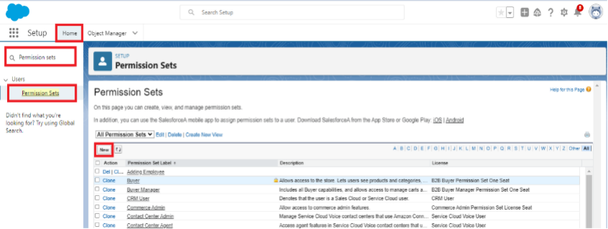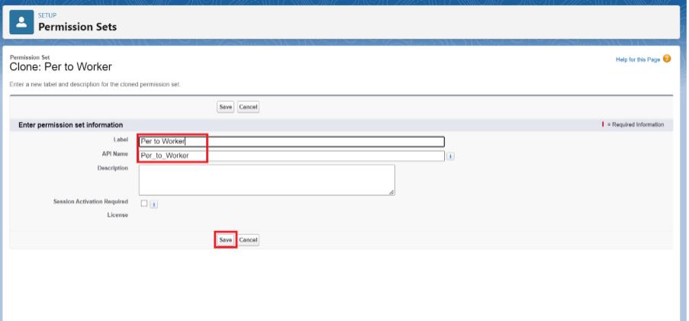

A permission set is a collection of settings and permissions that give users

access to various tools and functions. Permission sets extend users' functional

access without changing their profiles. Users can have only one profile but,   
depending on the Salesforce edition, they can have multiple permission sets.

1. Go to setup >> type “permission sets” in quick search >> select   
 permission sets >> New.

1. Enter the label name as “Per to Worker”, API will be auto populated ?

save.

1. Under Apps Select object settings.

1. Click on Items object ? click on Edit ? under Item:Record Type   
 Assignments,enable Gold,Silver ? Object permission check for read ,edit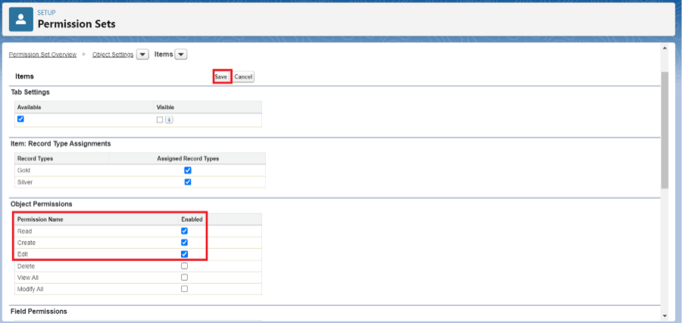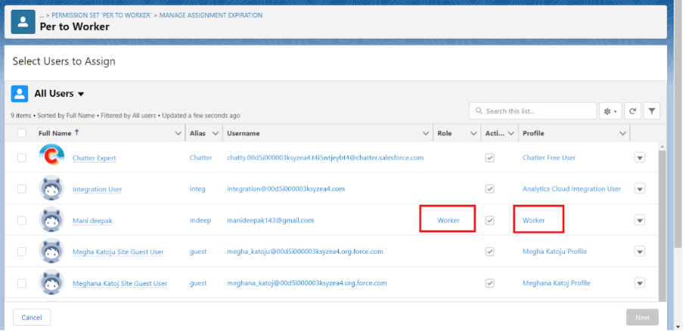

and create.

1. Click on Save.

1. After saving the permission click on the Manage assignment

1. Now click on the Add Assignment.

1. Now select the users which you have created in user milestone, using   
 Worker profile and click on Next ? Assign? Done.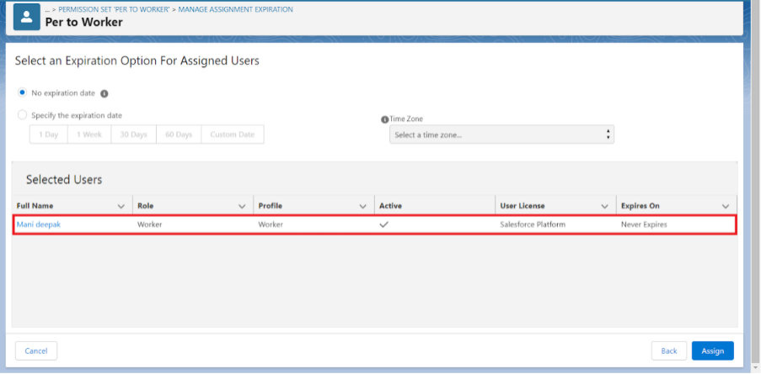

MILESTONE 12:TRIGGER

**Activity 1:Creating A Trigger Handler Class**

**Trigger handler:**

A trigger handler is a design pattern that organises trigger logic into separate   
classes. This helps in keeping code organised, reusable, and easier to maintain.

The trigger handler class contains methods that handle the specific logic for   
different trigger events, improving code structure and readability. This approach   
is particularly useful for complex triggers or projects with multiple triggers, as it   
promotes modular coding practices and reduces the chances of code   
duplication.

**CODE:**

public class UpdatePaidAmountTriggerHandler {

public static void handleBeforeInsert(List<Billing__c> newBillings) {

for (Billing__c billing : newBillings) {

billing.Paid_Amount__c = billing.Paying_Amount__c;

}

}

public static void handleBeforeUpdate(Map<Id, Billing__c> oldBillingsMap,

List<Billing__c> updatedBillings) {

for (Billing__c billing : updatedBillings) {

Billing__c oldBilling = oldBillingsMap.get(billing.Id);

Decimal oldPaidAmount = oldBilling.Paid_Amount__c;

billing.Paid_Amount__c = oldPaidAmount + billing.Paying_Amount__c;

}

}

**Activity 2:Create A Trigger**

CODE**:**

trigger UpdatePaidAmountTrigger on Billing__c (before insert, before update)

{

if (Trigger.isInsert) {

UpdatePaidAmountTriggerHandler.handleBeforeInsert(Trigger.new);

} else if (Trigger.isUpdate) {

UpdatePaidAmountTriggerHandler.handleBeforeUpdate(Trigger.oldMap,

Trigger.new);

}

}

MILESTONE 13:USER ADOPTION

**Activity 1: Create a Record (Jewel Customer)**

1. Click on App Launcher on the left side of the screen.

2. Search Jewelry Inventory System & click on it.

3. Click on Drop Down and Click on the Jewel Customer tab.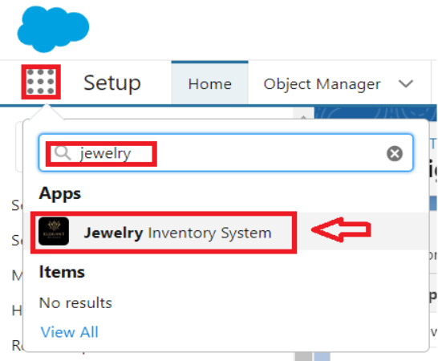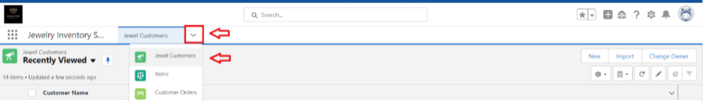

4. Click New.

5. Fill the Details and click on Save.

**Activity 2: View a Record(Jewel Customer)**

1.Click on App Launcher on the left side of the screen.

2.Search Jewelry Inventory System & click on it.

3. Click on the Jewel Customer Tab.

4. Click on any record name. you can see the details of the Jewel Customer

**Activity 3: Delete a Record(Jewel Customer)**

1. Click on App Launcher on the left side of the screen.

2. Search Jewelry Inventory System & click on it.

3. Click on the Jewel Customer Tab.

4. Click on Arrow at right hand side on that Particular record.

5. Click delete.

Note**:**Create at least 10 records for each of the objects: Jewel   
Customer,Price,Item,Customer Order and Billing.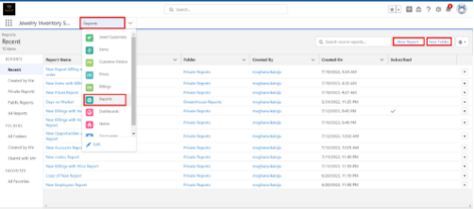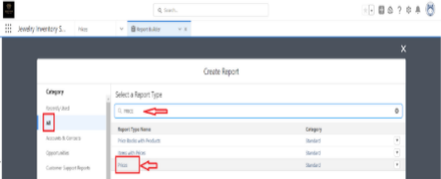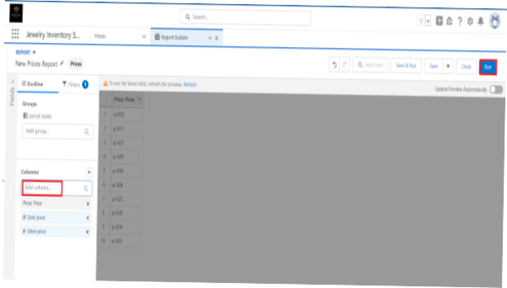

MILESTONE 14: REPORTS

**Activity 1 : Create A Reports**

1. Go to the app >> click on the reports tab

2. Click New Report.

1. Select report type from category or from report type panel or from search   
 panel ? click on start report.

1. Customise your report

●Add fields from the left pane as shown below.

1. Save or run it.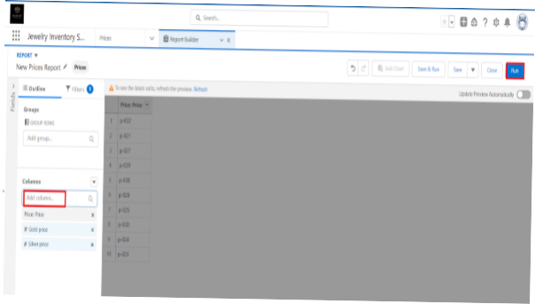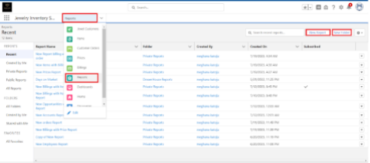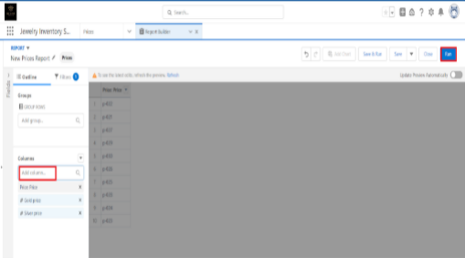

Note: Reports may get varied from the above pictures as the data might be

different.

**Activity 2:Reports**

1. Go to the app >> click on the reports tab

2. Click New Report.

1. Select report type from category or from report type panel or from search   
 panel ? click on start report.

Customise your report

●Add fields from the left pane as shown below.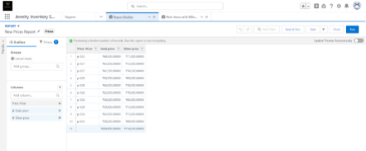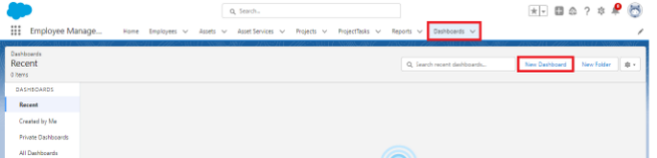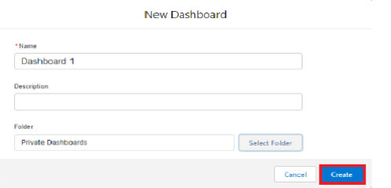

1. Save or run it.

Note: Reports may get varied from the above pictures as the data might be

different.

MILASTONE 15: DASHBOARDS

**Activity : Create A Dashboards**

1. Go to the app >> click on the Dashboards tabs.

1. Give a Name and click on Create.

1. Select add component.

1. Select a Report and click on select.

1. Click Add then click on Save and then click on Done.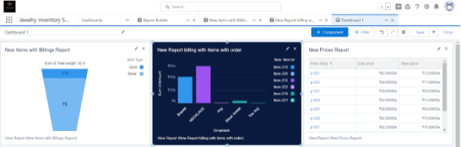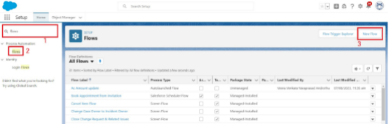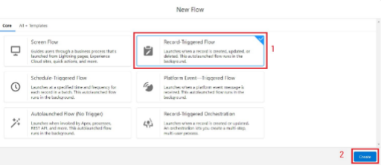

**Activity 2: Create another Dashboard as we discussed in activity 1.**

MILESTONE 16 : FLOWS

**Activity :Create A Flow**

1. Go to setup >> type Flow in quick find box >> Click on the Flow and

Select the New Flow.

1. Select the Record-triggered flow and Click on Create.

1. Select the Object as a “Billing” in the Drop down list.

1. Select the Trigger Flow when: “A record is Created or Updated”.

1. Select the Optimise the flow for: “Actions and Related Records” and

Click on Done.

1. Now change the mode form Auto-layout to free-form.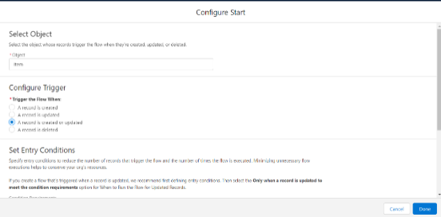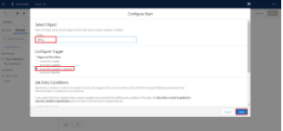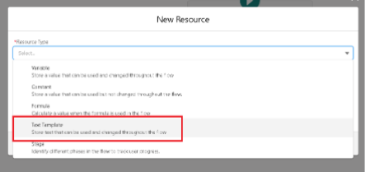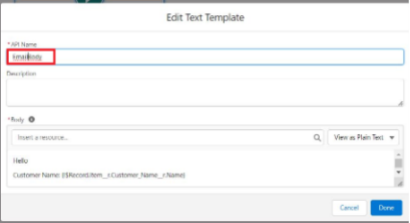

1. Now select the manger option in the toolbox, click New resource.

1. Select the resource type as text template.

1. Enter the API name as “ Email body”.

1. Change the view as Rich Text ? View to Plain Text.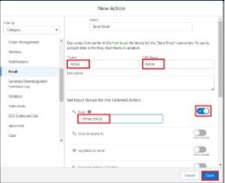

1. In the body field paste the syntax that is given below.

Hello

Customer Name: {!$Record.Item__r.Customer_Name__r.Name}

Here are the details for the item you purchased with Jewellery Inventory

System

Item Type: {!$Record.Item__r.Item_Type__c}

Ornament: {!$Record.Ornament__c}

Weight: {!$Record.Weight__c}grams

Amount: {!$Record.Amount__c}

1. Click done.

1. Now click on elements, and drag the action element into the preview

pane.

1. Their action bar will be opened in that search for “ send email ” and click

on it.

1. Give the label name as “ notice”

1. API name will be auto populated.

1. Enable the body in set input values for the selected action.

1. Select the text template that was created.

1. Include Recipient Address list, select the email form the record.

({!$Record.Item_r.Customer_Namer.Email_c})

1. Include the subject as “Welcome to Jewelry Inventory System ”.

1. Click done.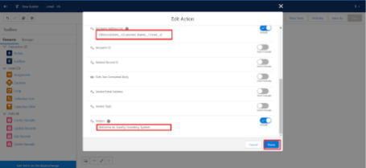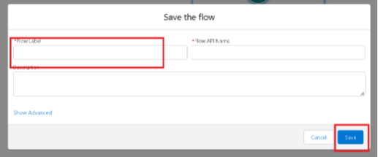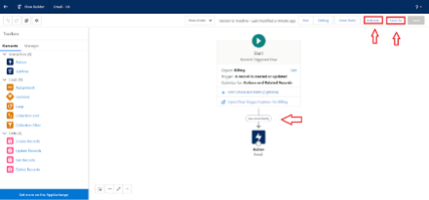

1. Now drag the path from the start to the action element.

1. Click on save. Given the Flow label , Flow Api name will be auto

populated.

1. And click save, and click on activate.

CONCLUSION

---

Conclusion

The CRM application for jewel management successfully streamlines and   
modernizes the way jewelry businesses manage their customer relationships,   
inventory, and sales processes. By integrating customer data, purchase history,   
and personalized preferences, the system enables jewelers to deliver a more   
engaging and customer-focused experience. Additionally, it enhances   
operational efficiency through features such as order tracking, sales analysis,   
inventory management, and follow-up reminders.

This project demonstrates how a CRM tailored to the jewelry industry not only   
improves customer satisfaction and loyalty but also assists business owners in   
making informed decisions based on real-time data. Overall, the application   
provides a sustainable, user-friendly, and scalable solution that bridges the gap   
between traditional jewelry business practices and modern digital

transformation.

---